**Week 1 Module 2.2 Assignment Debugging**

Juan Macias Vasquez

Bellevue University

CSD325-H323 Advanced Python (2255-DD)

**Jack Lusby**

June 1st, 2025

Module 2.2 Assignment: Documenting Debugging

From Intro to Programming with Python Module 4.2 Assignment

Miles To Kilometers Program

Results Document

Original Program

# Juan Macias Vasquez

# Date 04/05/2025

# Module 4.2 Assignment Miles to Kilometers

def Converter(miles):

"""Convert miles to kilometers."""

return miles * 1.60934 # Multiples miles to get kilometers

def main(): # Main interface for the user

while True:

try:

miles = float(input("Enter the number of miles you drove: ")) # Gets input from user

if miles < 0:

print("Do Not Enter Negative Number. Please enter a valid number.") # Makes sure the number isnt negative

continue

break

except ValueError:

print("Invalid input. Please enter a number.") # Makes sure a number is entered

# Output

kilometers = Converter(miles)

print(f"\nYou entered: {miles} miles")

print(f"That's equivalent to: {kilometers} kilometers")

if __name__ == "__main__":

main()

**Debugging version**

**Set Breakpoint and Debug**

miles = float(input("Enter the number of miles you drove: ")) # Gets

to

mmiles = float(input("Enter the number of miles you drove: ")) # Gets

I added an extra m in the front of miles which lead to miles becoming undefined in the code and after asking the user for the number of miles the code would just stop and crash

Screenshot of debug

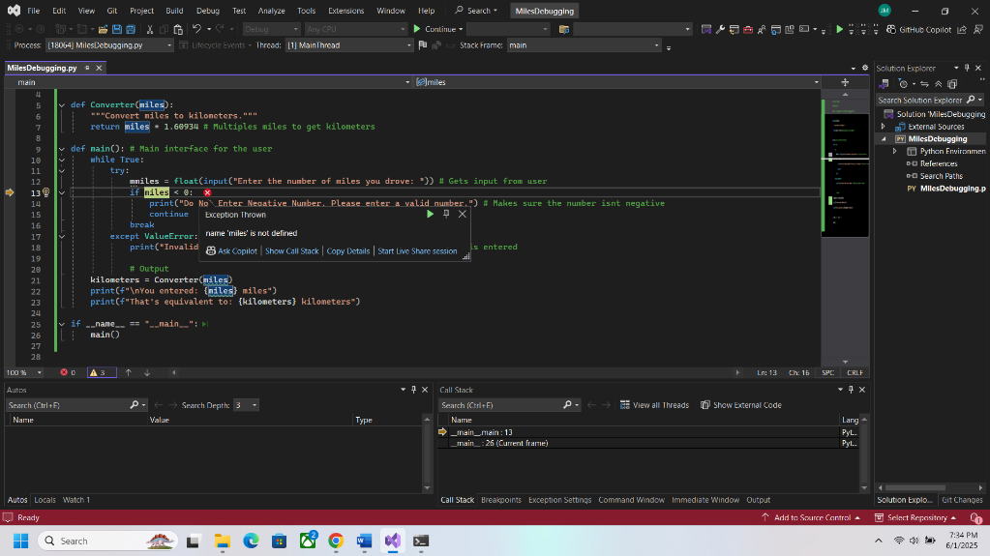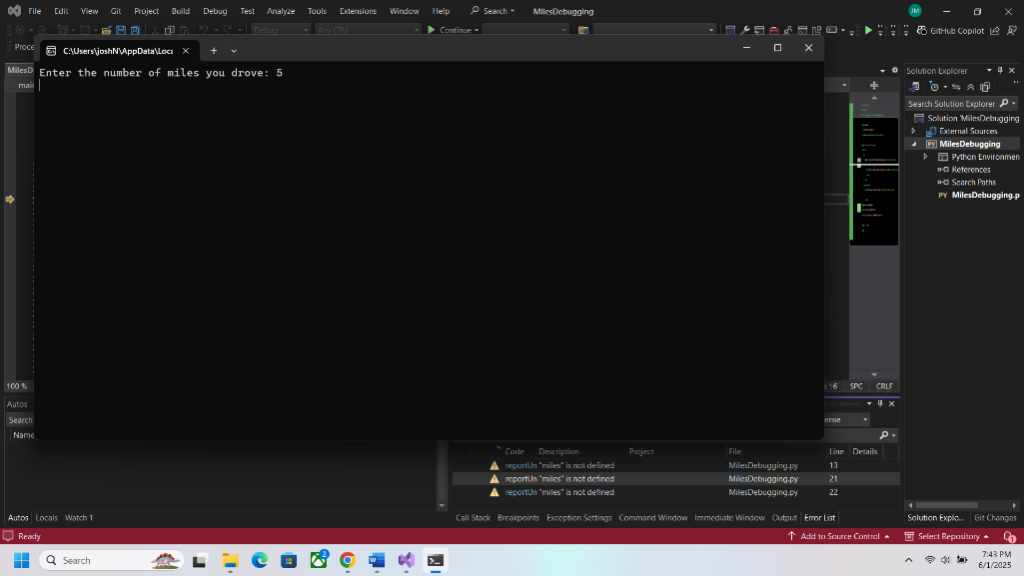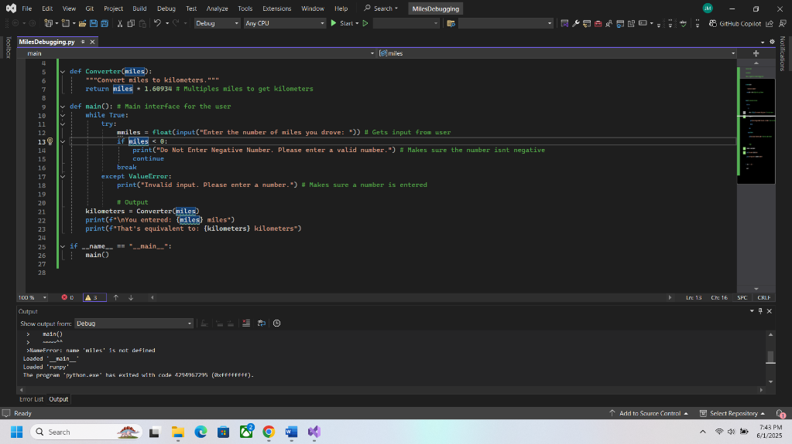

Second Bug

This time the main issue is that the number of miles for under 0 was changed to “number” and it doesn’t know what it was looking for due to the wrong name used.

